**Changes to the HC website – desktop version**

1. Arrows are duplicated here (below and beside):
   1. [Austria | Homecare](https://www.freseniuskabi-homecare.at/)

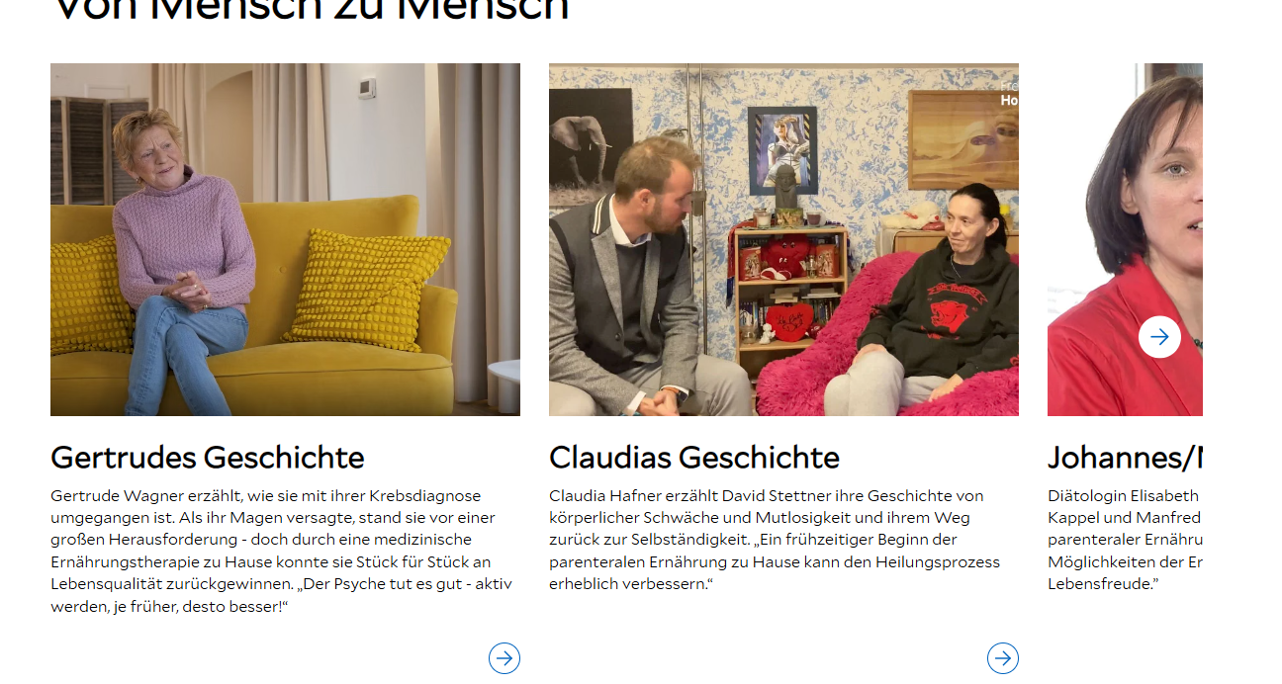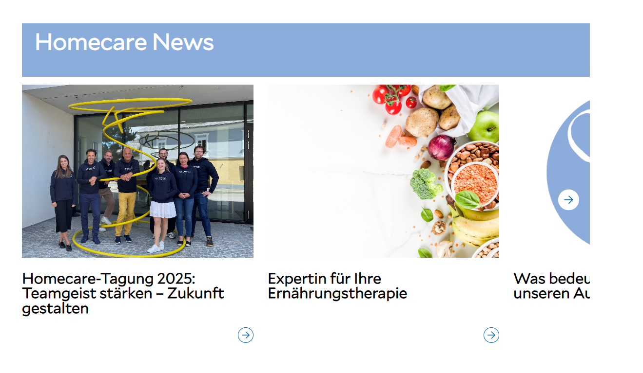

1. Images are too large (bad quality)
   1. [Über uns | Homecare](https://www.freseniuskabi-homecare.at/ueber-uns)

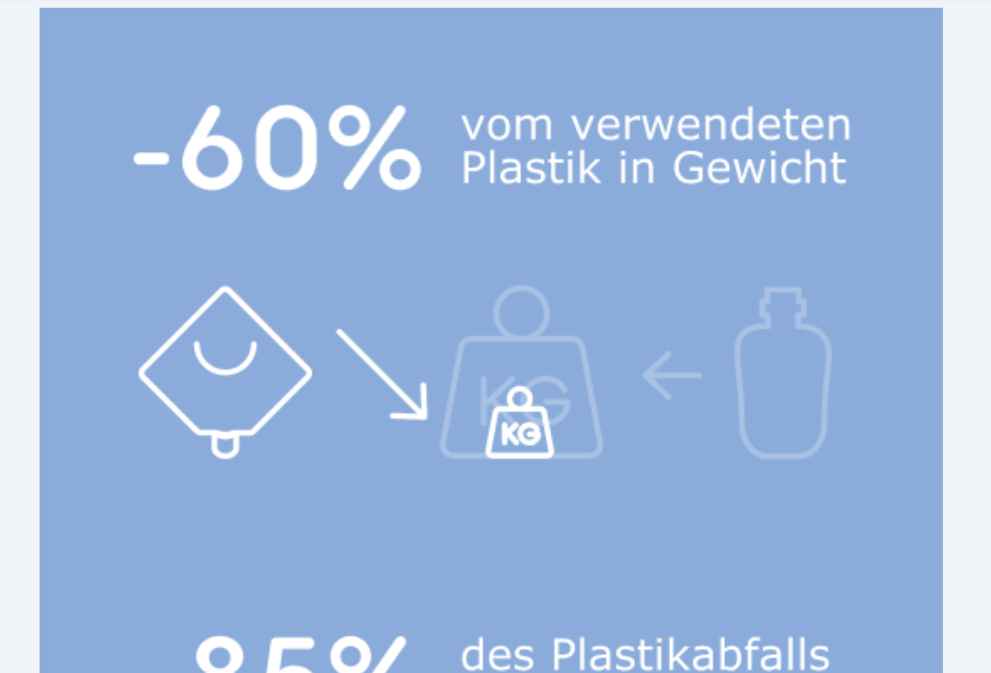

1. Carousel display is not optimal (text is partially cut off, images jump) - It depends on the zoom factor
   1. [Patient:innen | Homecare](https://www.freseniuskabi-homecare.at/patient-innen/patient-innen#carousel-c8b8421e1d-item-07b43df03c-tabpanel)
   2. [Fachkräfte | Homecare](https://www.freseniuskabi-homecare.at/fachkraefte/fachkraefte#carousel-c10f3289f6-item-c61b4f8540-tabpanel)

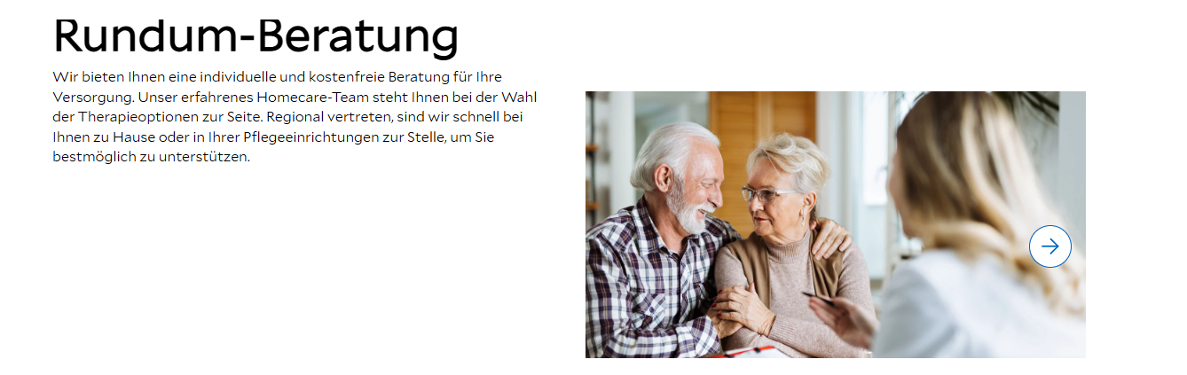

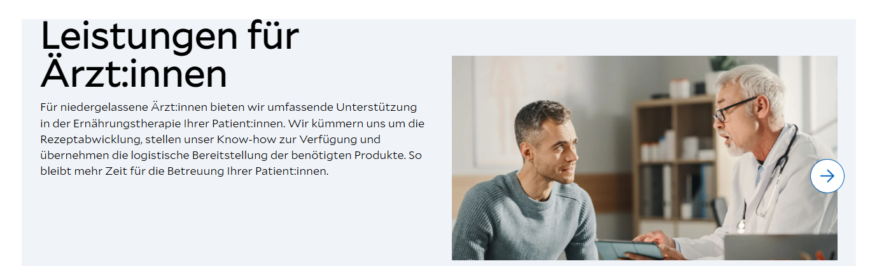

**Changes to the HC website – mobile version**

1. The news feed on mobile doesn’t look optimal, and one page is missing.
   1. [Austria | Homecare](https://www.freseniuskabi-homecare.at/)

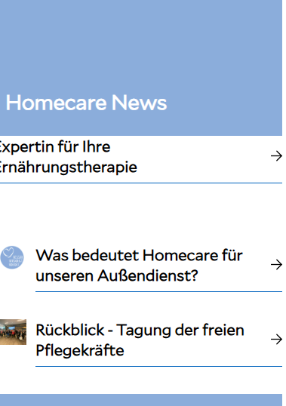

1. Carousel display is not optimal (text is partially cut off, images jump) - It depends on the zoom factor
   1. [Patient:innen | Homecare](https://www.freseniuskabi-homecare.at/patient-innen/patient-innen#carousel-c8b8421e1d-item-07b43df03c-tabpanel)
   2. [Fachkräfte | Homecare](https://www.freseniuskabi-homecare.at/fachkraefte/fachkraefte#carousel-c10f3289f6-item-c61b4f8540-tabpanel)
2. There is too much space between the pictograms.
   1. [Patient:innen | Homecare](https://www.freseniuskabi-homecare.at/patient-innen/patient-innen#carousel-c8b8421e1d-item-07b43df03c-tabpanel)
   2. [Fachkräfte | Homecare](https://www.freseniuskabi-homecare.at/fachkraefte/fachkraefte#carousel-c10f3289f6-item-c61b4f8540-tabpanel)

